
SCOUTING
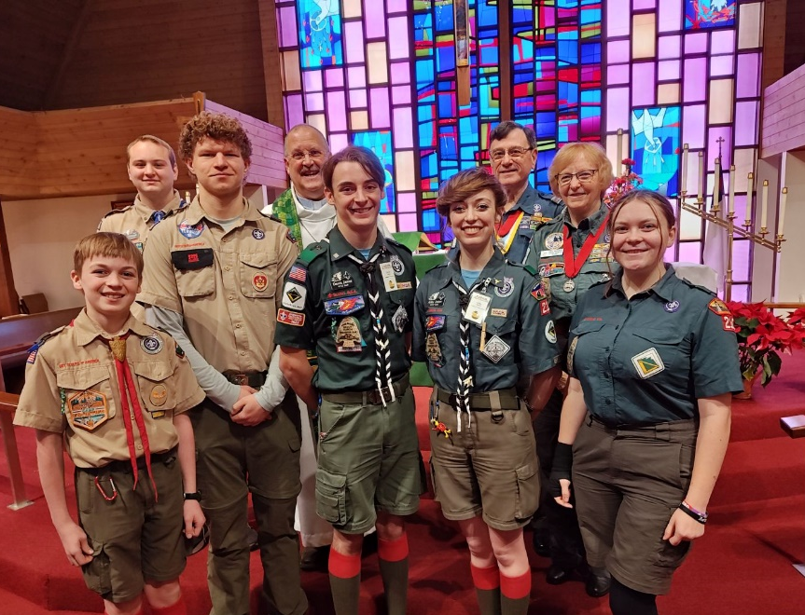


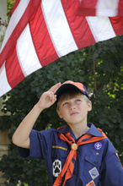

A Resource for
Lutheran Youth
Ministry in
Congregations
and Schools



Scouting Programs
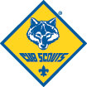
Cub Scouting is a family-centered program for boys and girls in kindergarten through fifth grades, organized by grade levels called dens. At each grade level, Cub Scouts qualify for rank badges by completing age-appropriate adventures in the areas of: Character/Leadership, Outdoors, Personal Fitness, Citizenship, Personal Safety, and Family/Reverence.

Youth in kindergarten(Lion) and first grade(Tiger) join with an adult partner. As Cub Scouts move up in grade levels, they also move up in rank programs: second grade(Wolf), third grade(Bear), fourth grade (Webelos). The fifth-grade Arrow of Light program of adventures prepares them for a good start in the Scouts BSA program. Cub Scouting’s emphasis is on the interaction of boys and girls with their parents learning through fun-filled adventures.

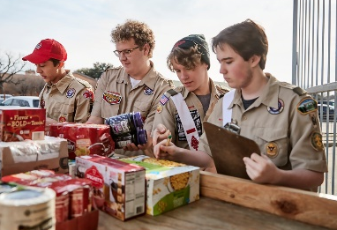
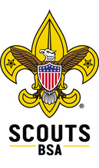
Scouts BSA is for boys and girls ages 11 through 17. The program is designed to achieve its aims of citizenship, physical fitness and moral development through a vigorous outdoor program and peer leadership with mentoring provided by caring adult leaders. Scouts BSA is an excellent way for young people to develop leadership skills, a passion for service, and experience personal growth while participating in fun challenges and adventures with other Scouts.



Venturing is for young men and women who are 14 to 21 years of age. Venturing provides positive experiences through exciting and meaningful activities in the areas of Adventure, Leadership, Personal growth and Service (ALPS). These experiences help youth pursue their special interests, to grow and develop citizenship and leadership skills, and to prepare them to be positive influences within their schools, congregations, and communities.

Developmental Assets
Scouting: A Resource for Youth Ministry
Your Lutheran congregation or school wins:
- Scouting becomes a valuable resource and an important part of your youth ministry programs.
- Scouting will help keep your young people connected to your congregation’s or school’s beliefs and teachings, as well as connected to positive role models.
- The religious emblems program will help create an arena in which young adults can interact with religious leaders.
- Scouting provides a program that can attract other young people in the community to an ongoing involvement with your congregation’s activities and beliefs.
- Scouting in your youth group will help display your Christian concern and action in the welfare of the community.

The youth win:
- Scouting stimulates youth interest in wholesome, fun activities sponsored by your congregation or school and can strengthen their commitment to their faith and help them live out that faith in their church and community.
- In Scouting, young people are taught hands-on leadership skills such as planning, listening, teamwork, communication, and delegation.
- Scouting’s advancement programs help young people feel recognized, provide a sense of belonging, and build positive self-esteem.

The adult volunteers win:
- Scouting provides an opportunity for greater community involvement.
- Scouting enhances communication, planning, and program development skills.
- Scouting encourages a greater commitment to service.
- Volunteers receive specific program suggestions that can be tailored to the needs of the youth group.
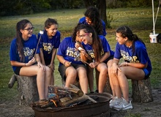

Scouting Resources for
Religious Organizations
- Youth protection training and criminal background checks for adults (required)
- Youth protection training for youth and parents
- Liability insurance coverage
- Access to local BSA camp property for religious retreats and team building
- Position-specific training for adult volunteers
- Religious emblems programs
- Professional guidance on how to:
  - Organize the program
  - Recruit youth members and adult volunteers
  - Connect with other Scouting leaders
  - Conduct annual planning meetings
  - Plan and tailor your program to achieve your congregation’s or school’s aims
- Program helps such as:
  - Leader’s manuals
  - Monthly/weekly meeting plans
  - On-line supplemental training
  - A Activities with other Scouting units
- Service projects to benefit your congregation, school or community

Religious Growth Programs
Scouting recognizes the religious growth programs of Programs for Religious Activities with Youth (P.R.A.Y.) for Lutheran young people and adults:
Youth Religious Emblems
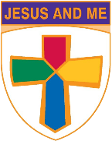
Jesus and Me Grades K-1
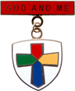
The Jesus and Me curriculum introduces Jesus as the Son of God in familiar terms so that young children can see Jesus in their own day-to-day experiences as a storyteller, teacher, friend, and healer.
God and Me Grades 2-3

The God and Me curriculum is designed to help children become best friends with Jesus and tell their story of “God and Me” together.
God and Family Grades 4-6

The God and Family curriculum is designed to help youth understand the importance of family and God’s role in a healthy family.
God and Church Grades 6-8
The God and Church curriculum is designed to lead youth on a three-part faith journey – Meeting Christ, Worshipping God, Witnessing and Ministering for Christ.


God and Life Grades 9-12
The God and Life curriculum is designed to help students understand their call to a life of discipleship. Students will explore what it means to live one's life for Christ.
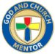
God and Country Mentor Program (adult curriculum)
A mentor is someone who serves as a living example for another person. The God and Country mentor program is designed to help adults look directly at what it means to serve as a Christian mentor, and it suggests how to have a positive, Christian influence on a child. The mentor curriculum is designed for an adult working with a young person enrolled in the God and Country program series. An adult who completes the mentor studies will receive a certificate and lapel pin for non-uniform wear. The mentor program is not to be confused with the Lamb and Servant of Youth adult recognitions (see below).

Adult Lutheran Religious Recognitions
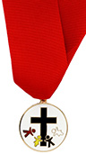
The Servant of Youth and the Lamb adult recognitions are given to acknowledge distinguished volunteer service in ministry to young people through one or more civic youth agency programs.

A Servant of Youth recipient may be Lutheran or of another Christian congregation who has a minimum of five years’ service to Lutheran youth.
A Lamb Award recipient must be Lutheran and have a minimum of ten years’ distinguished service to the Lutheran Church and its youth.

An adult does not apply for these awards, but is nominated by other Scouting leaders and their Lutheran congregation. Nomination forms for these awards are available from P.R.A.Y. and local BSA councils.
Information and materials concerning the religious emblems programs can be obtained from any local BSA council office, the National Lutheran Association on Scouting (www.NLAS.org) or from
Programs for Religious Activities with Youth (P.R.A.Y.) 11123 S. Towne Square, Suite B, St. Louis, MO 63123-7816; Phone: 800-933-7729; Web site: www.praypub.org;
e-mail at: info@praypub.org

GETTING STARTED
Steps to Organize a Scouting Unit in Your Congregation or School
Secure a commitment from the head of your Lutheran congregation or school.
Conduct a briefing meeting of key leaders. The head of your congregation or school calls a meeting of key members in the organization with a representative from the local BSA council in attendance. The representative can:
- Explain how Scouting works within the framework of the congregation or school.
- Determine the market for Scouting within the congregation or school and the community.
- Describe adult leader roles and responsibilities; discuss prospects to fill adult leadership positions; explain required youth protection training and background check procedures.
- Help identify a key adult to serve as the chartered organization representative – a liaison between the congregation or school and the Scouting units (pack, troop, crew)
Conduct planning and training meetings. Youth Scouting committee and leaders meet with a BSA representative to begin leader training and plan program for the first six months.
Schedule the organizational meeting.
- Youth members are recruited and program explained to parents.
- Regular unit meetings begin.
- Unit is installed and charter is presented at a formal service before the congregation or student body.

It’s Our Turn to Make a Difference!
Scouting is a good place to make a difference in the life if a child. A Louis Harris study of youth in various Scouting programs demonstrates that Scouting supports health development among youth. Harris also found that youth involved in Scouting learn to get along with others, give their best effort, have confidence in and set goals for themselves, care for other people, treat others with respect, and take better care of the environment. Another important finding was the high correlation between Scouting and future achievements, taking the form of improved high school and college graduation rates and higher household incomes.
Scouting meets developmental needs through age-specific programs. In Cub Scouting, the strong bonds between children and parents are reinforced with interpersonal time doing projects together, going places together and just talking together. Parents have found that character-related values communicated to Cub Scouts result in respecting the environment, staying away from drugs, and even helping out more at home.
As youth grow older and develop a need for greater independence, they enter Scouts BSA, which is designed to foster their growth in skills and personal character. Scouts have indicated that Scouting has encouraged them to feel pride in America, to learn the difference between right and wrong, and to strengthen their relationship with God. We know that high portions of the membership of Scouting feel that the program has prepared them for a successful future by teaching those skills they may not have learned elsewhere. Recognition by the worldwide community if Scouting’s value system bears strong testimony to the value of personal growth in self-esteem and sense of usefulness gained by members at meetings.

The National Lutheran Association on Scouting
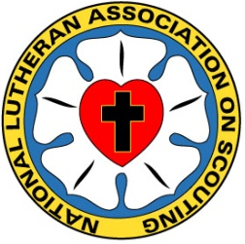
Recognized by the Evangelical Lutheran Church in America (ELCA) and the Lutheran Church Missouri Synod (LCMS), the National Lutheran Association on Scouting (NLAS) is a nation-wide volunteer group made up of Scouters dedicated to assist all Lutheran congregations, schools, organizations and leaders to use the programs and resources of the Boy Scouts of America and other youth organizations as a means of ministry to children, youth, and families.
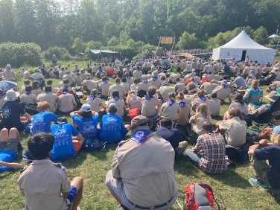
The association offers program and worship resources; youth, adult, and unit recognitions and certificates; a quarterly newsletter and Facebook page; adult training conferences at the Philmont Training Center; plus information and worship at BSA national events such as Jamborees. Find full information at:
www.NLAS.org

Words to Live By
The Scout Oath
On my honor I will do my best
To do my duty to God and my country
and to obey the Scout Law;
To help other people at all times;
To keep myself physically strong,
mentally awake, and morally straight.

